**Bibliography**

 Java books

1. Schildt

2. Balaguruswamy

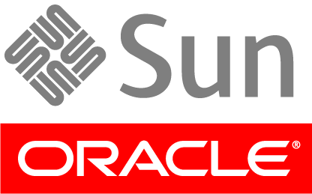 www.oracle.com

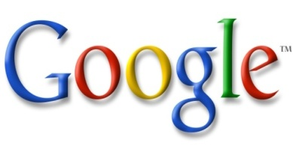 1. Project papers on java

2. Games source code

3. Google scholar

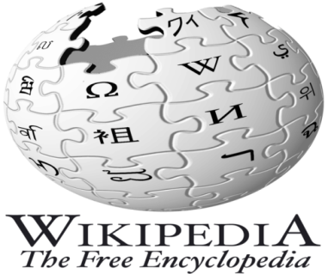 Wikipedia.org